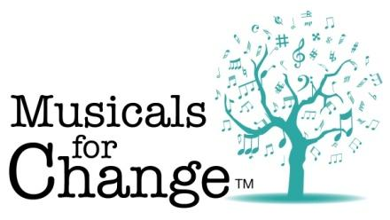

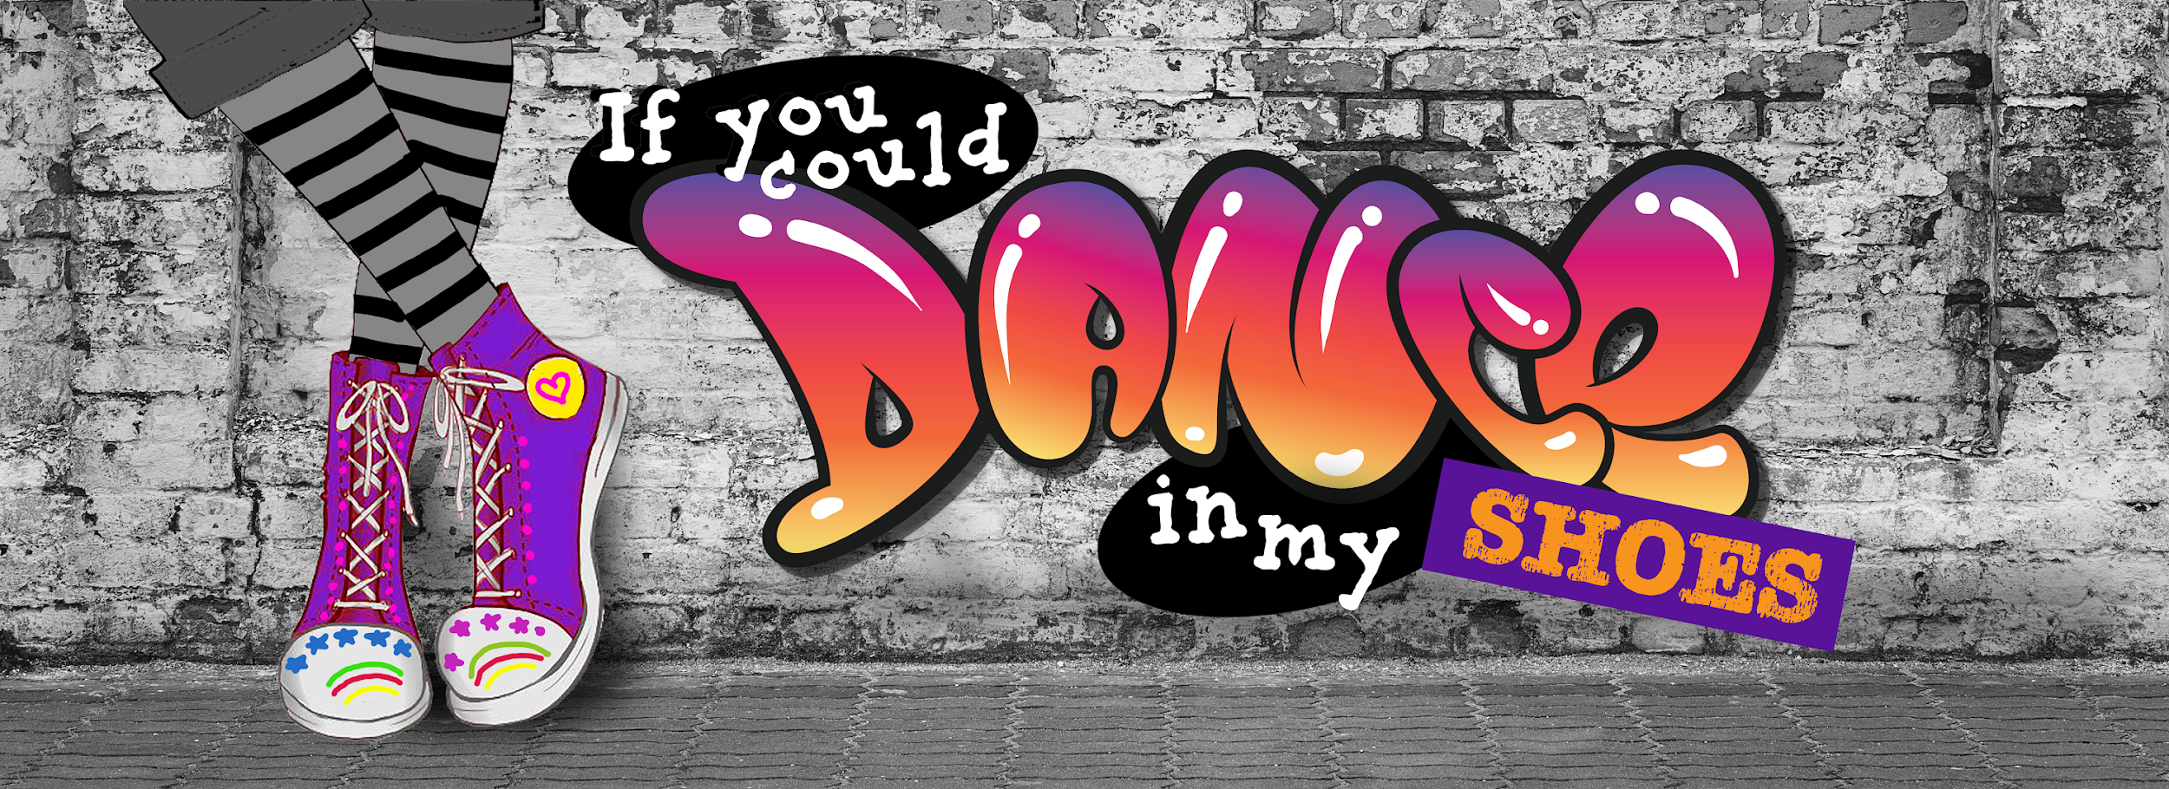
Student Script (Lyrics Only)
Book and Music by Diane Beckstead

To Benefit

©2021 D. Beckstead
Musicals for Change
musicalsforchange.com
All Rights Reserved

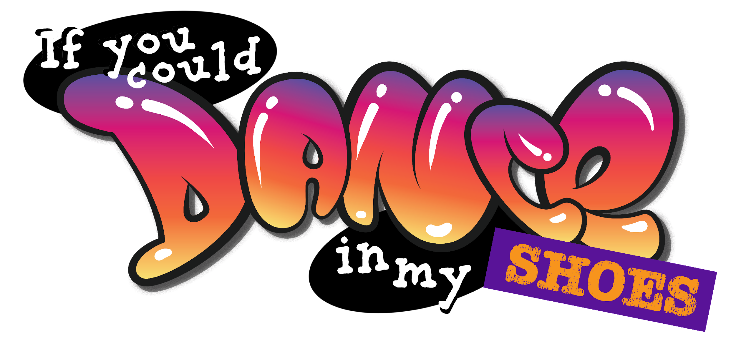
Book and Music by Diane Beckstead

Unison/Two Part
Approximate Running Time: 60 minutes
Arranged by Joe Milton and Diane Beckstead
Produced by Joe Milton, JOMUSIK Studios
Score and Script prepared by
Francis Caravella, Opus Now! Publications
and Diane Beckstead
Graphic Design by Melissa McVaugh

Recordings performed by
Joe & Loralai Milton

CAST

PENNY: Homeless, lives in a car with her dad, friendless and made fun of by classmates
FINN: Homeless, a little older than Penny, kind, with wisdom beyond his (or her) years
ALEAH: Penny’s classmate, befriends Penny, supportive
TRAVIS: Well-off, dad owns shoe store chain, always looking to make a buck
KELLY: Teenage clerk at Shiney’s Shoe Shop
SAM: Mail carrier (boy or girl)
JORDAN: Child whose shoes were stolen (girl or boy)
BRAYDEN: Classmate (girl or boy)
ALI: Classmate (girl or boy)
VOICES: Dad, teacher
Various classmates, shoe store customers

SONGS AND TRACKS
Title | Performer(s) | Page #  Stu / Dir |  | Audio Track  Reh / Perf
School Bell | Sound Effect | 4 | 4 |  | 1
1. What’s a Penny Worth? | Ensemble (except Penny) | 4 | 4 | 1 | 2
1a. What’s a Penny Worth? – Reprise (Scene Change) | Instrumental | 6 | 11 |  | 3
City Street Sounds | Sound Effect | 7 | 12 |  | 4
City Bus stopping, then leaving | Sound Effect | 8 | 13 |  | 5
2. If You Could Walk in My Shoes | Penny | 9 | 14 | 2 | 6
City Bus idling, then leaving | Sound Effect | 11 | 20 |  | 7
2a. If You Could Walk in My Shoes – Reprise (Scene Change) | Instrumental | 11 | 20 |  | 8
2b. What’s a Penny Worth? – Reprise (Scene Change) | Instrumental | 13 | 22 |  | 9
3. The Flatter Patter Rap | Travis, Ensemble | 14 | 23 | 3 | 10
3a. The Flatter Patter Rap – Reprise (Scene Change) | Instrumental | 18 | 31 |  | 11
City Bus | Sound Effect | 19 | 32 |  | 12
4. Sparkle and Color | Ensemble | 20 | 33 | 4 | 13
4a. Sparkle and Color – Reprise (Scene Change) | Instrumental | 23 | 42 |  | 14
5. Partners | Travis, Ensemble | 24 | 43 | 5 | 15
6. Kick It Up! | Ensemble | 28 | 52 | 6 | 16
6a. Kick It Up! – Reprise (Scene Change) | Ensemble | 29 | 57 |  | 17
7. Service, I Want Service | Ensemble | 30 | 58 | 7 | 18
7a. Service, I Want Service – Reprise (Scene Change) | Instrumental | 32 | 62 |  | 19
City Street Sounds | Sound Effect | 33 | 63 |  | 20
8. Let It Shine (This Little Light) | Finn, Ensemble | 36 | 66 | 8 | 21
8a. Let It Shine – Reprise (Scene Change) | Finn, Ensemble | 37 | 72 |  | 22
8b. If You Could Walk in My Shoes – Reprise (Scene Change) | Instrumental | 40 | 75 |  | 23
9. Gotta Dance | Ensemble | 41 | 76 | 9 | 24
10. Finale | Penny, Ensemble | 43 | 83 | 10 | 25

SCENE ONE – CLASSROOM
(Children at desks, facing audience. BRAYDEN is sleeping, PENNY is doodling)
TEACHER: (Offstage voice) Class, Benjamin Franklin is famous for more than his role as a signer of the Declaration of Independence. Can you name some other things he is known for?
(STUDENT 1 raises hand quickly)
TEACHER: Yes?
STUDENT 1: He did experiments with electricity. He was a scientist.
TEACHER: Right. Anything else?
(STUDENT 1 diligently takes notes on all that is said)
STUDENT 2: Didn’t he start the post office?
TEACHER: Yes! We owe our mail delivery to Ben Franklin. Brayden, any ideas?
(BRAYDEN, who had been sleeping, is startled to hear his/her name)
BRAYDEN: What? Um…Mexico?
(All laugh)
TEACHER: Ben Franklin. We’re talking about Ben Franklin.
(BRAYDEN looks embarrassed, shrugs)
STUDENT 3: (raises hand) Didn’t he invent our money?
TEACHER: Yes. Very good. Ben Franklin created the first penny, but those early pennies were twice the size of todays’ pennies. Eventually people got tired of carrying all that heavy metal in their pockets, so the coins were made smaller. How much is a penny worth?
(All hands except PENNY’s shoot up)
TEACHER: (focusing hopefully on PENNY) Penny?
PENNY: (who had been doodling, looks up) One cent. (Continues to doodle)
TEACHER: Right, but the value has dropped so much that you really can’t buy anything with one penny today.
ALI: Then why do they still make them?
TEACHER: Soon they may not. A penny isn’t even worth the copper it’s made from.
Cue Sound Effect 1. School Bell
TEACHER: Time to pack up. Remember what we talked about today!
Cue Track 2. What’s a Penny Worth?
(During song, desks are cleared, backpacks are packed and put on. PENNY is avoided at all costs.)
ALI: (to classmates) So Penny isn’t worth anything.
BRAYDEN: We already knew that!
(PENNY shoots him a defiant look. Other students laugh)
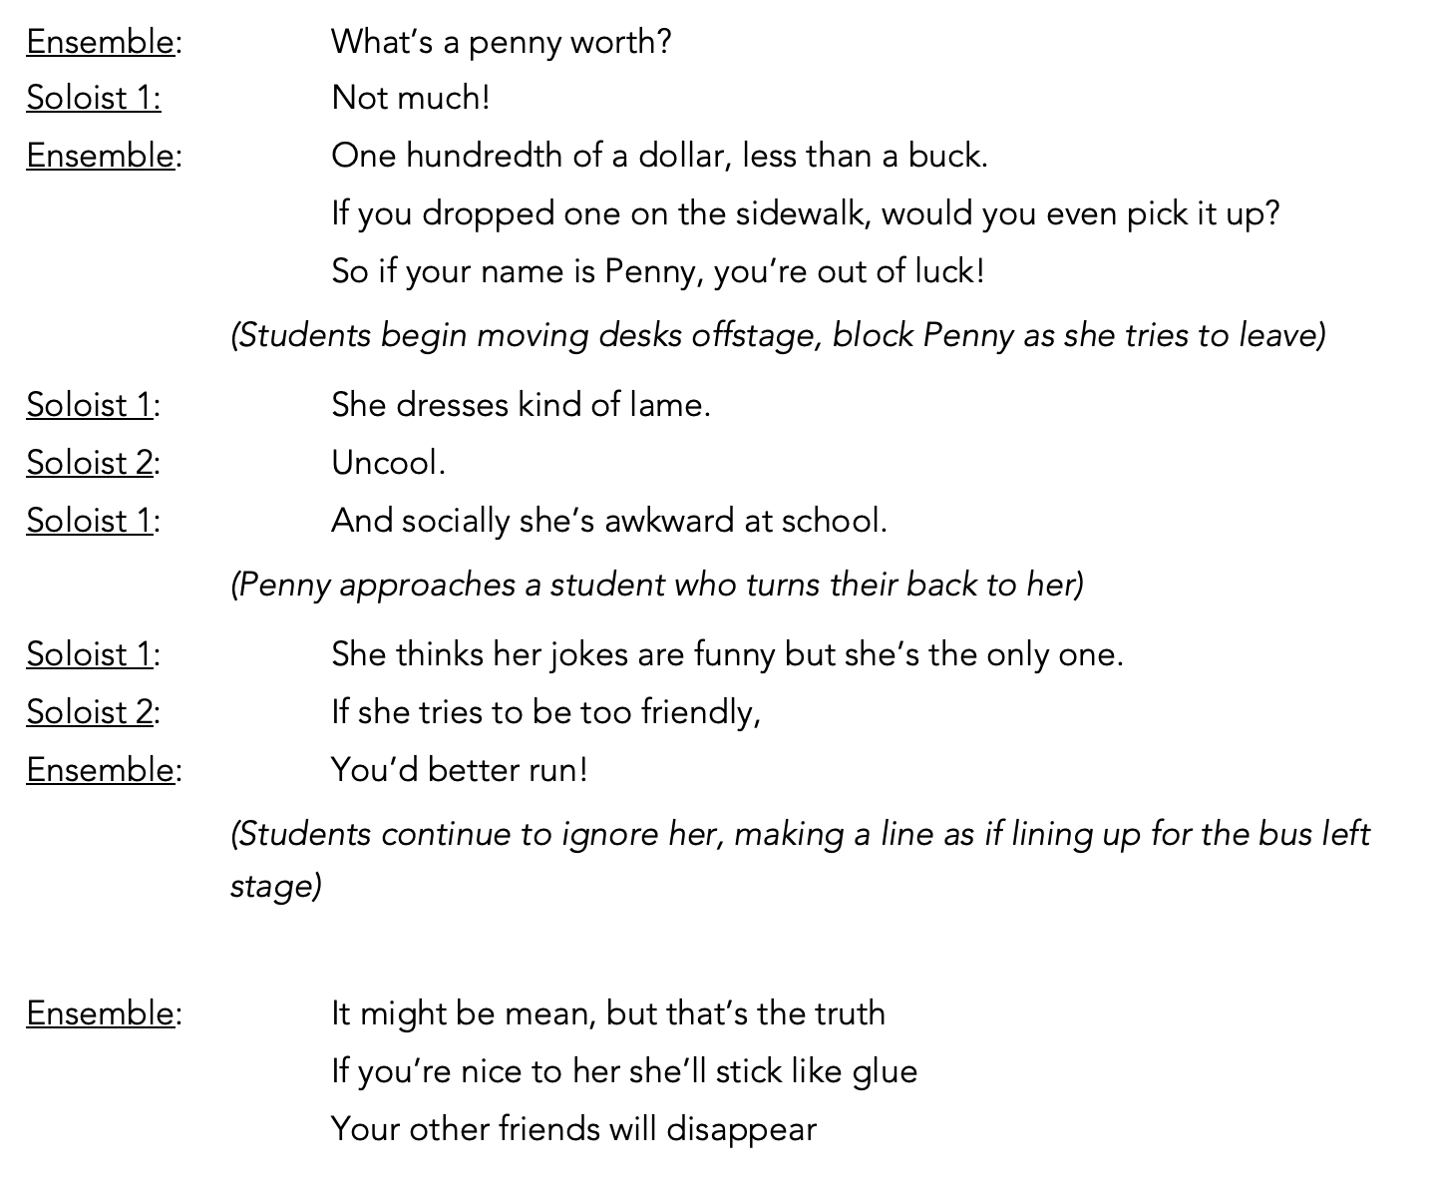
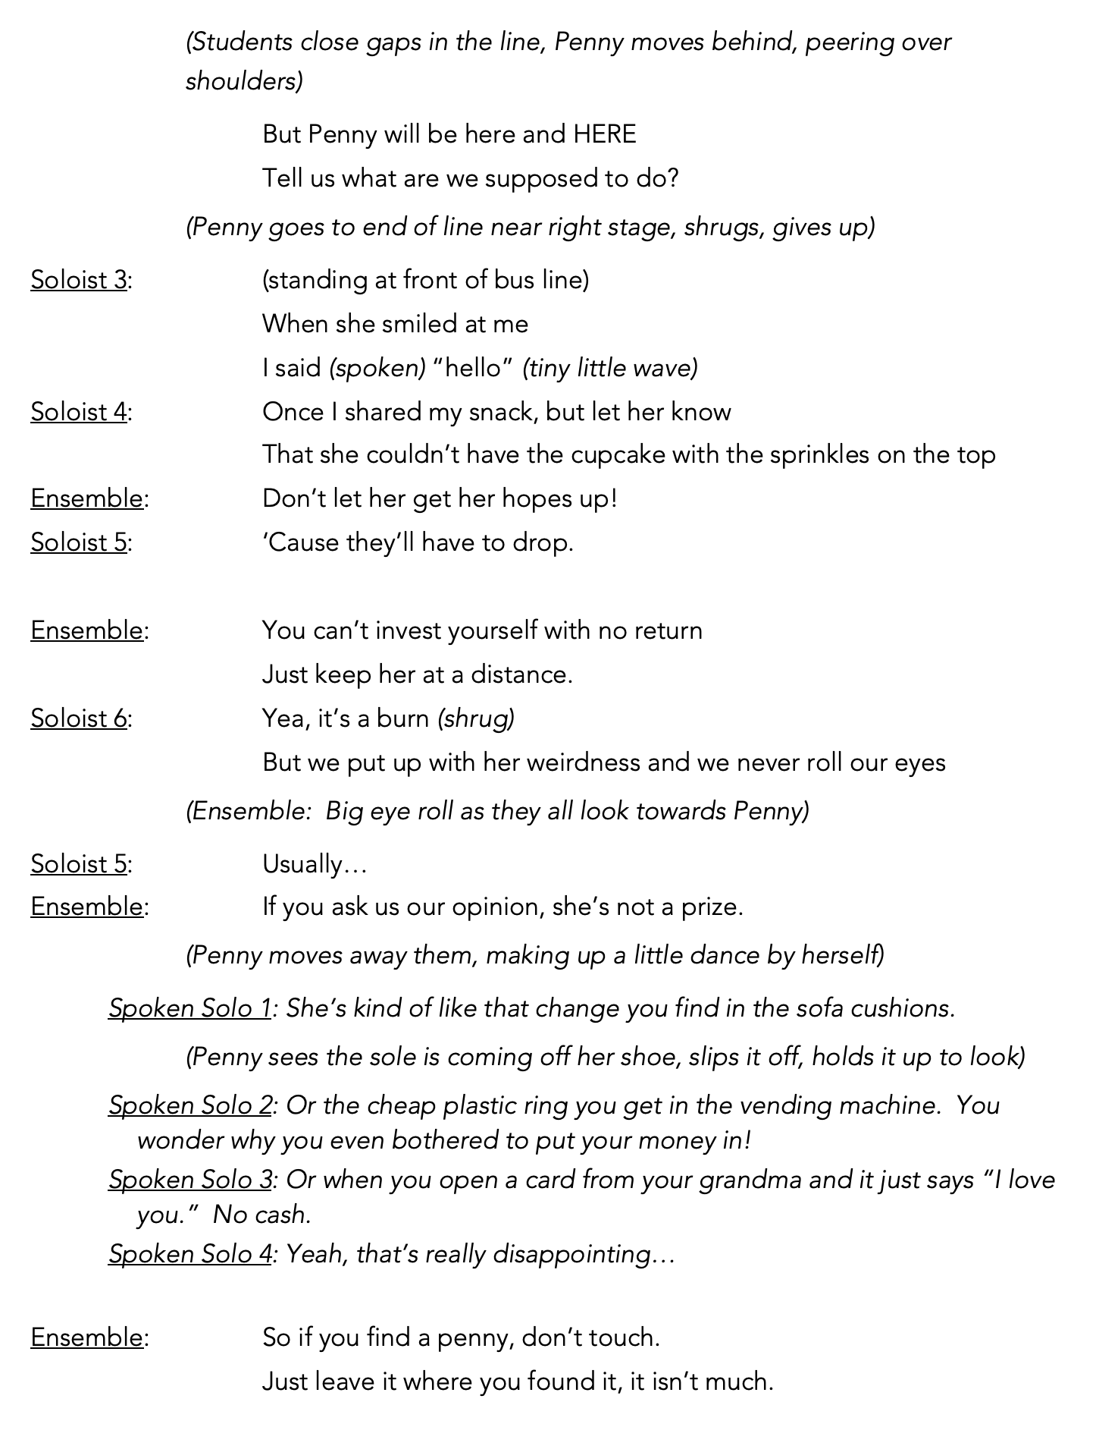
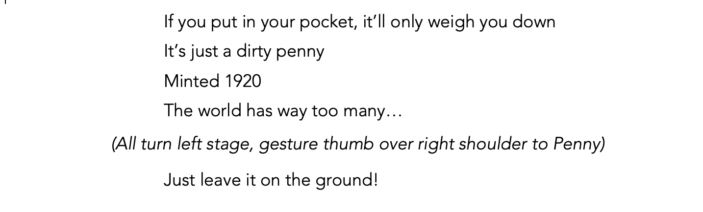
(Penny hurriedly puts her shoe back on. Student's line exits stage left with Penny quickly following)
Cue Track 3. What’s a Penny Worth? – Reprise (Scene Change)

(Blackout)
SCENE TWO – PENNY’S STREET
(Car parked on street, park has benches, garbage can, bus stop sign)
Cue Sound Effect 4. City Street Sounds
(Lights up)
PENNY: (From inside car, opens door, leans out) Dad! Dad! Wait! I need money for new shoes! Mine are falling apart!
DAD: (Offstage Voice) Sorry, honey. I’m late for work. Get some duct tape. It’s in the trunk!
PENNY: Dad! (Sighs.)
(PENNY climbs out of car barefoot, goes to trunk and rummages around, coming up with a roll of duct tape and shoes. She sits down and wraps them in duct tape. Looking at them, she sighs, then looks for her backpack. She tosses the roll into the backpack, pulls a hairbrush out, and attempts to brush her unruly hair. She finds mismatched socks, sniffs them, puts them on, puts her taped shoes on, throws the backpack over her shoulder, and walks to a bench at a bus stop. As she sits, she looks in her bag and finds a snack-size bag of chips. She begins to eat. Various pedestrians hurry by on their way to work. FINN sits down on a different bench, reading a paper and people-watching.)
(TWO STUDENTS approach bus stop, pausing a few feet from the bench. One points to PENNY’s shoes. They laugh together and then walk to the bench.)
(Fade sound effect cue)
STUDENT 1: (Sitting next to PENNY) Nice shoes. (smirks)
PENNY: (Eating) What? Oh.
(Realizing she is being made fun of, PENNY turns sideways on the bench to hide her shoes. The other student walks behind the bench to her side to look at her shoes.)
STUDENT 2: So, is that the newest thing? Duct-tape shoes?
PENNY: (Stops eating) I have other shoes……but I couldn’t find them and I was late.
STUDENT 1: I thought you were just early for Halloween. They make you look like Frankenstein. (He does a Frankenstein walk, arms extended, legs moving without bent knees, grunting. STUDENT 2 laughs.)
(PENNY stuffs chips into her backpack. Turns her back to students. More kids arrive at the bus stop and laugh at the Frankenstein act)
STUDENT 3: (To STUDENT 1) What’s wrong with you?
(STUDENT 1 grunts)
STUDENT 3: What?
STUDENT 2: He’s Frankenstein. Like Penny. Look at the shoes.
(Students look down and laugh. PENNY tucks feet under bench, looking down.)
Cue Sound Effect 5. City Bus stopping, then leaving
(Students exit to take the bus, but PENNY stays where she is. When the bus leaves, she pulls her knees up to her chin. Various people cross in front of her bench, but no one notices her. FINN puts paper down, gets up and walks toward PENNY.)
FINN: (sits down on the other end of PENNY’s bench) Hey.
PENNY: (looking up briefly, then back down) Hey.
FINN: How come you didn’t get on that bus?
PENNY: Why should I?
FINN: Aren’t you going to school?
PENNY: Aren’t you?
FINN: (shrugs) I’m home-schooled.
PENNY (sarcastically) Lucky you.
FINN: (shrugs) Maybe. (pauses, looks at her feet) Nice shoes.
PENNY (rolls her eyes) Not you, too.
FINN: Well, they could be better. You’ve gotta be a little creative. See these?
(FINN straightens his legs to show off his shoes. They are laced with bright string in a pattern, the tongue and sides are brightly patterned duct tape.)
FINN: These were in pretty bad shape. I just added some stuff. See?
(PENNY stays where she is but looks slightly interested.)
FINN: You just use better tape, lace them different with crazy colors.
PENNY: Not bad.
FINN: You use what you’ve got.
PENNY: I haven’t got much.
FINN: Me either. But I’ve got a brain. (he points to his temple)
PENNY: Hm.
FINN: So do you.
PENNY: (Sarcastically) Right. I’m brainy. And fashionable. (Sticks feet out) Soon I’ll be prom queen.
(They sit in silence for a few seconds watching people go by. Music begins)
Cue Track 6. If You Could Walk in My Shoes

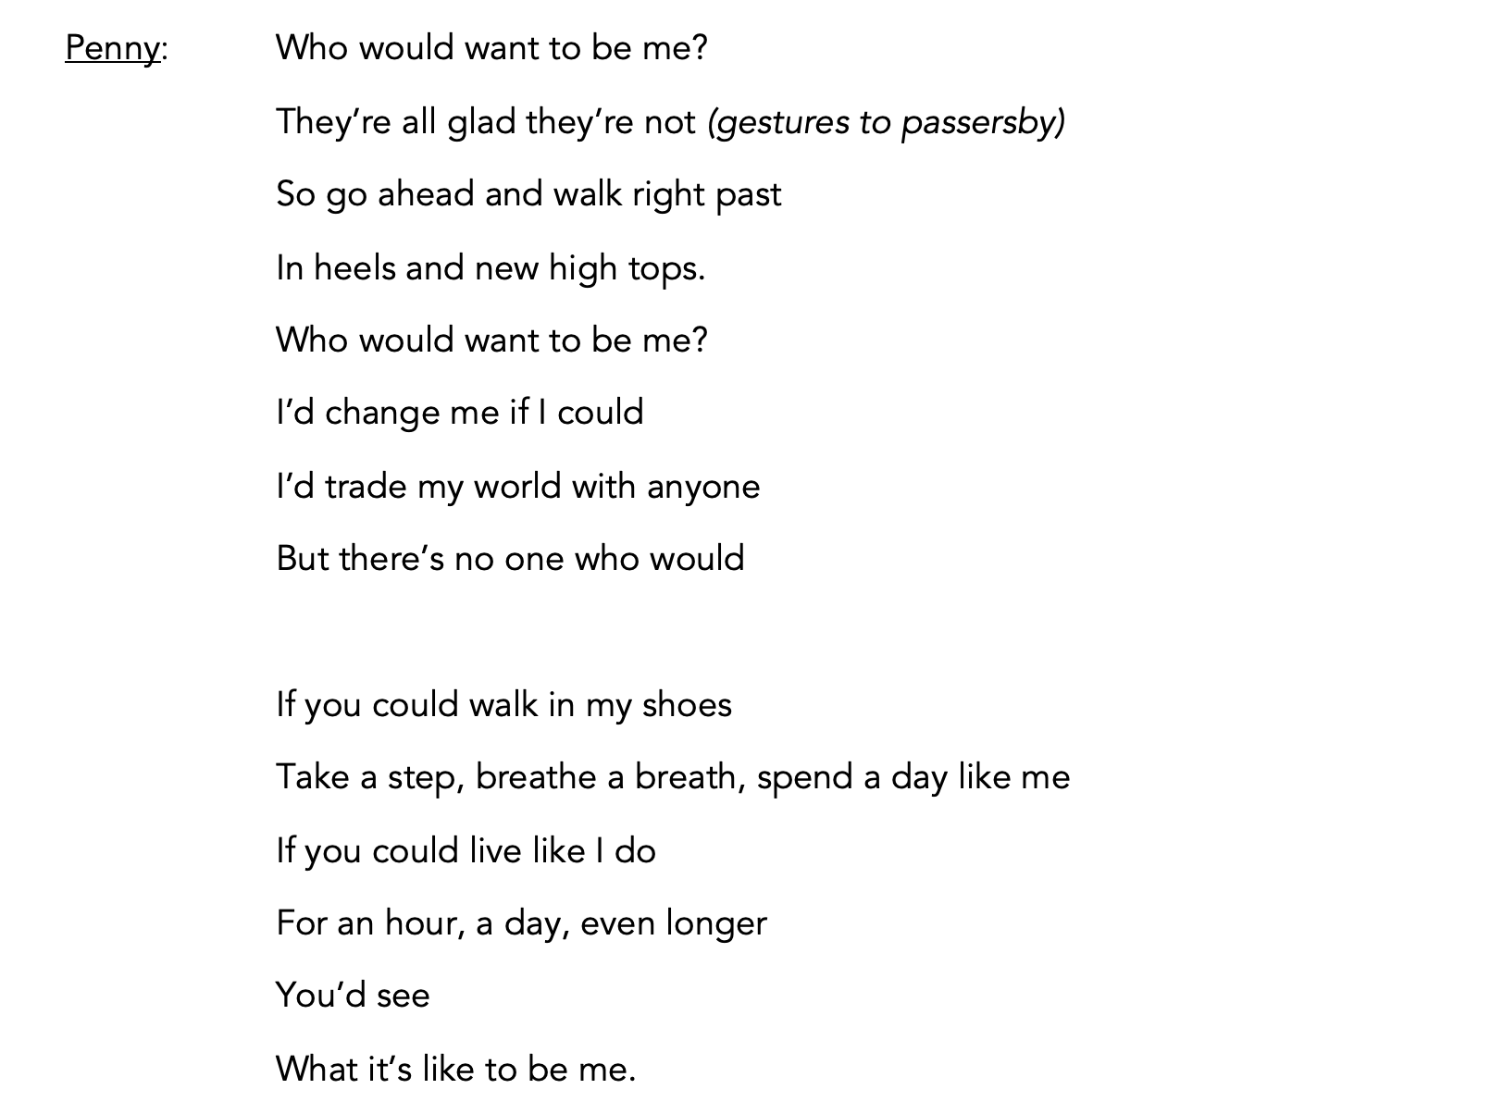
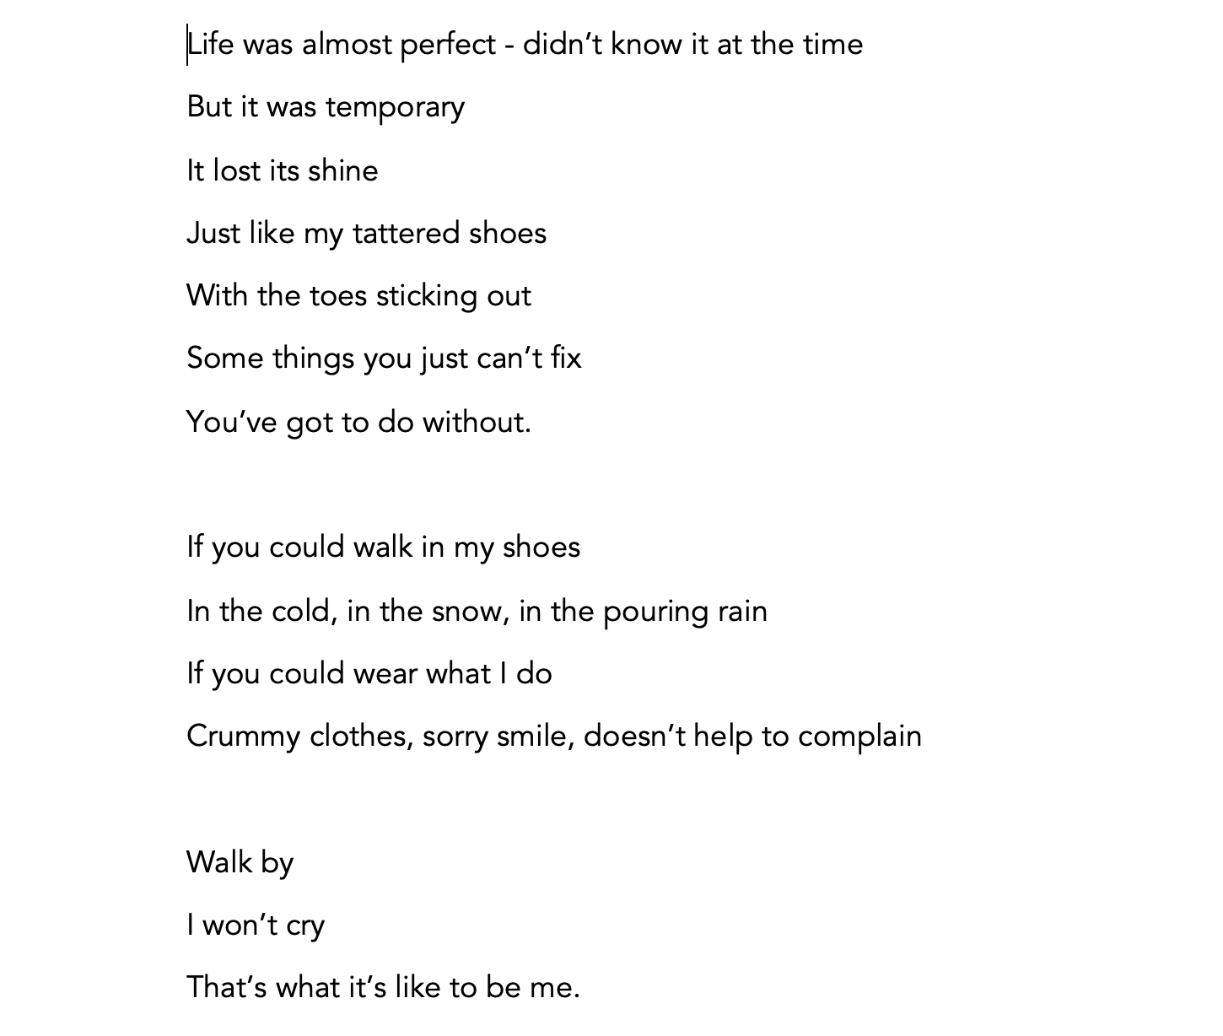

FINN: So… shoes aren’t your only problem?
PENNY: You wouldn’t understand. Shouldn’t you be going home? (Sarcastically) Getting that schoolwork done?
FINN: This is home.
PENNY: The park?
FINN: Home is wherever there’s a floor to sleep on.
(PENNY looks at him, comprehending.)
FINN: (He shrugs) You learn a lot. (Pause)
FINN: Hey, here’s an idea. If you want, I could loan you my shoes, you could give me yours, and while you’re at school I’ll dress them up. Fix the laces. You won’t even recognize them.
PENNY: (Interested now) Really? You’d let me wear your shoes?
FINN: Why not?
PENNY: You really want my shoes? They’re so ugly.
FINN: They won’t be. Just meet me here after school.
(PENNY shrugs and takes her shoes off)
FINN: (Handing her his shoes) Here. Try these on.
PENNY: How do you know I’ll give them back?
FINN: If you don’t, I can make yours look just as good as those. (gestures to his shoes as she puts them on)
(PENNY stands, moves feet back and forth to see how they look on her feet)
PENNY: These are pretty awesome. Thanks!
FINN: No problem. See you later.
Cue Sound Effect 7. Bus idling, then leaving.
FINN: You’d better catch that bus.
PENNY: (Grabs her backpack, turns to go) Thanks, uh….?
FINN: Finn.
PENNY: I’m Penny. See you after school!
(She dashes off)
Cue Track 8. If You Could Walk in My Shoes – Reprise (Scene Change)

SCENE THREE – ART CLASS AT SCHOOL
(PENNY, in paint apron, works at an easel by herself. ALEAH works at an easel nearby. PENNY hums, does a little dance while she paints. Other students look from behind easels and snicker while she dances, but ALEAH is the only one who talks to her.)
ALEAH: (looking down at PENNY’s feet) Nice kicks.
PENNY: (smiling) Thanks! A friend made them.
ALEAH: Awesome. I like the pattern with the laces. Very artsy.
PENNY: Yeah. Me, too! (She continues to dance while she paints)
TEACHER (Offstage Voice) Penny, please stop bouncing around and work on your project.
ALEAH: (Smiles, nudges PENNY) Looks like your new shoes got you into trouble!
PENNY: (To Aleah) I can’t help it! They make my feet dance! (They giggle)
(PENNY does a little dance step as TRAVIS walks by, and she accidently bumps into him.)
TRAVIS: Hey, watch it!
PENNY: Oops. (In a singing voice) Sorrrrrryyyyyy! (Smiling, she dances away)
TRAVIS: You’re lucky I didn’t stomp on your stupid shoes.
PENNY: You can’t catch them! (Does a few quick steps. Aleah laughs.)
TRAVIS: You should come to my dad’s store and buy some real shoes.
PENNY: These are real shoes.
TRAVIS: Yeah, right.
ALEAH: (To PENNY) He’s just jealous. His dad sells shoes but he doesn’t have anything cool like those at his store.
TRAVIS: (boasting) My dad’s got the best shoe store around. He has a whole chain of stores! Shiney’s Shoe Shops. They’re all over the state. And someday, they’ll be my stores!
PENNY: Sounds like you’ve got some big shoes to fill! (She laughs loudly and slaps her leg while ALEAH smiles. Other students roll their eyes, and TRAVIS makes a noise of disgust before walking away.)
TEACHER: (Offstage Voice) Okay, class, time to clean up. Make sure you wash your brushes really well.
ALEAH: (To PENNY) I have some old shoes that I like, but they look kind of bad. Do you think your friend could help me decorate them like yours? I’ve got some colored duct tape, paint and sequins.
PENNY: (Excited) Sure! Can you meet me at the park after school? On 10th Street?
ALEAH: Okay. I’ll bring glue and stuff.
PENNY: Great! And you can meet my friend Finn.
TEACHER: (Offstage voice) Let’s go, class! Clean up and get in line!
(PENNY dances happily as she cleans up)
Cue Track 9. What’s a Penny Worth? – Reprise (Scene Change)

SCENE FOUR – SHINEY’S SHOE SHOP
(A busy, chaotic scene.)
(TRAVIS is hurrying, delivering shoeboxes to customers who are trying on shoes. An older woman approaches him.)
CUSTOMER 1: Excuse me, young man, I’d like to try this shoe in a size 8 wide.
TRAVIS: (sweetly) Are you sure, Ma’am? You have such tiny feet. You couldn’t possibly wear an 8 wide!
(Kelly, another clerk who is putting shoes in boxes, smiles at Travis)
CUSTOMER 1: (Flattered) Oh, my. You’re so sweet.
(She pinches his cheek. TRAVIS smiles, then turns away and grimaces, rubbing his cheek.)
(A little girl enters with her mother)
LITTLE GIRL: Mommy, I want pink shoes!
TRAVIS: (overhearing her) I have the perfect shoes for you!
(TRAVIS pulls a brightly-colored pair of shoes off the shelf and shows her. She squeals with delight.)
LITTLE GIRL: Mommy, I want those!
GIRL’S MOTHER: I don’t know……they look expensive…
TRAVIS: But they’re 50% off this week if you buy another pair. (To mother) And I have a pair just like them for you in an adult size. You two could match!
(He pulls a similar pair off the shelf.)
LITTLE GIRL: Mommy, let’s match! Let’s look the same!
(They sit to try on shoes,)
TRAVIS: (moving to KELLY, who has been watching) And that… (does mic drop or other confident gesture) …is how it’s done.
Cue Track 10. The Flatter Patter Rap

(Music begins while TRAVIS continues to celebrate his sales ability with any appropriate gestures or dances, possibly dancing around Kelly while she watches him with arms folded.)
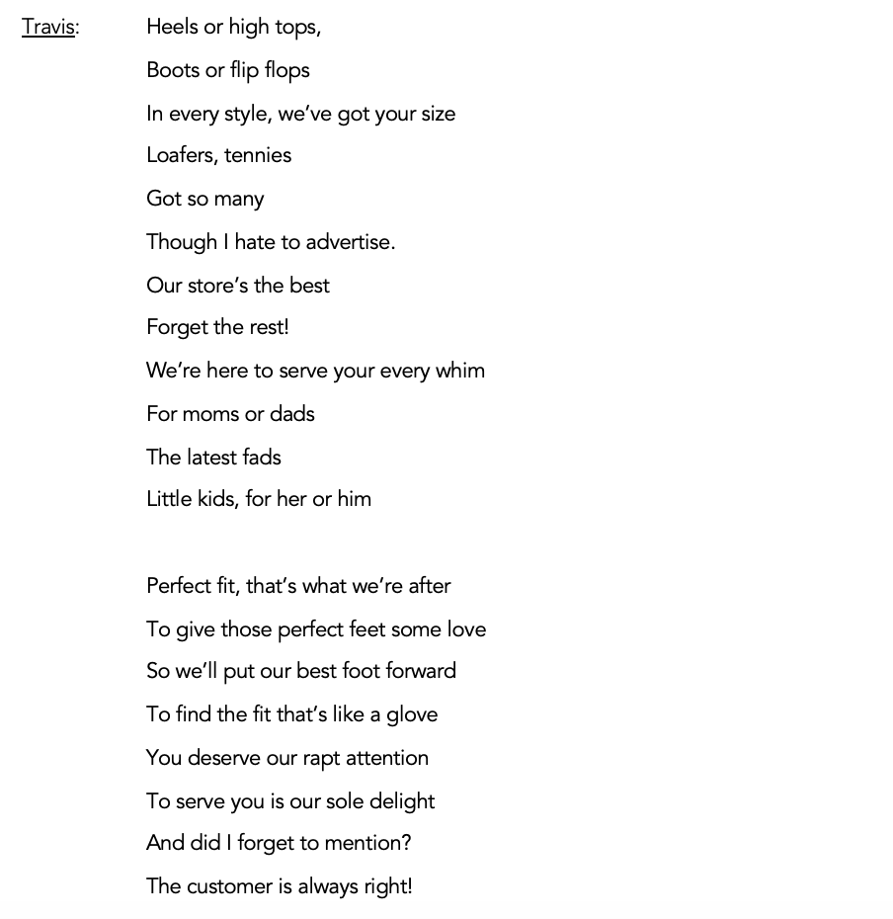

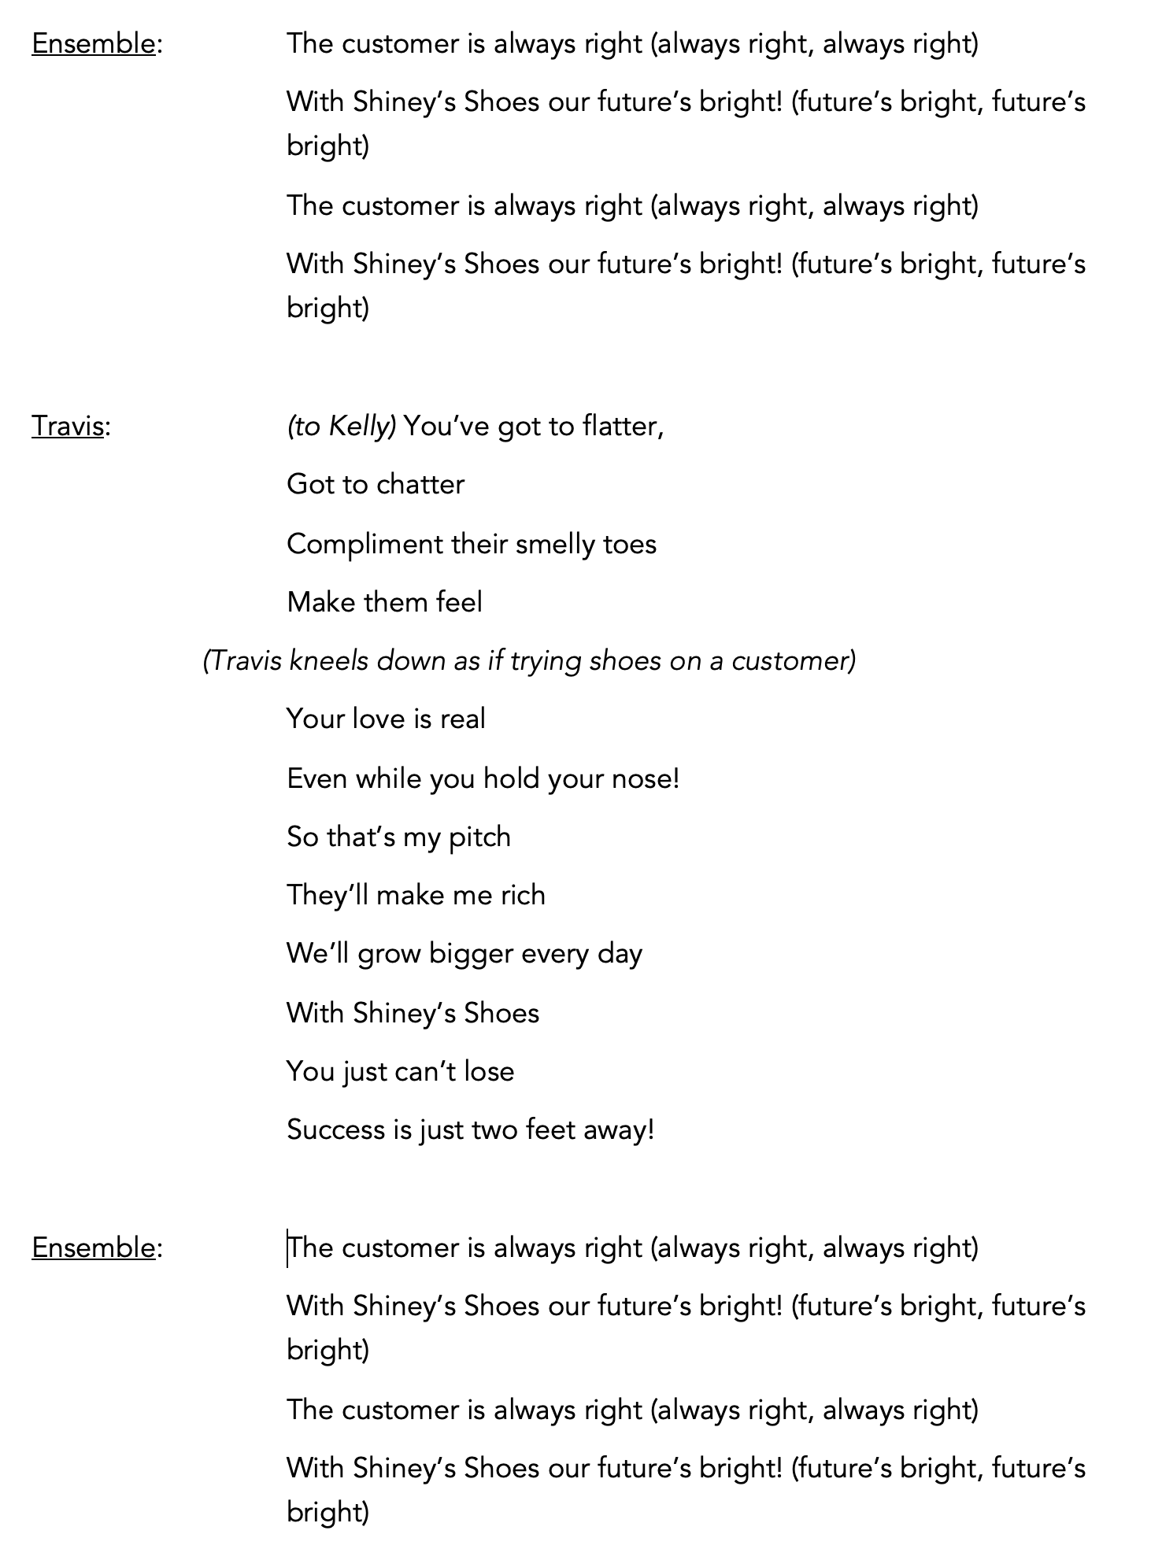
(While music gradually fades, customers line up at the cash register, hand TRAVIS or KELLY their money, and leave with their shoeboxes.)
TRAVIS and KELLY: (over singing, ad lib) Thank you! Have a good day! Come back again!
(Last to leave are the MOTHER and LITTLE GIRL.)
TRAVIS: (at cash register to Mother) Thank you for your business, Ma’am. Please come again. (To child) Would you like a lollipop?
LITTLE GIRL: Yes, please!
(TRAVIS hands her a lollipop)
MOTHER: What do you say?
LITTLE GIRL: (Looking at TRAVIS adoringly) Thank you! I love my new shoes!
TRAVIS: (Pats her on the head) You’re welcome. Come again!
(MOTHER and LITTLE GIRL exit)
TRAVIS: (With a fist pump) Yes!
(KELLY shakes her head at his extreme self-congratulation.)
(SAM, the mail carrier, enters)
SAM: (Entering cheerfully) Mail for Shiney’s Shoe Shop! Here you go, Travis. (hands him a stack of mail) Don’t you ever leave this place? After school you should be out playing ball or riding your bike.
TRAVIS: (Taking the mail) Nah, I’d rather be here. I’ve already sold 15 pairs today!
SAM: You’re making your dad proud. Someday you’ll own this store! But don’t work too hard. Remember, you’re still a kid.
TRAVIS: I know.
SAM: How is your dad? I haven’t seen him in a while.
TRAVIS: Traveling on business again. But he leaves me and Kelly in charge (gestures to her)
SAM: That’s a lot of responsibility for a kid.
TRAVIS: But I got this! Thanks, Sam.
(SAM waves and exits)
(TRAVIS sorts through the mail, pulling out one large envelope. He opens it and his eyes light up. He calls to KELLY who is stacking boxes)
TRAVIS: Hey, Kelly, look at this.
(KELLY walks over and peers over his shoulder as he reads.)
TRAVIS: “The Shiney’s Shoe Shop management is running a promotion for all Shoe Shop employees. The salesperson who sells 500 pairs of shoes by the end of the month will receive a $1,000 bonus!” My dad didn’t tell me about this!
KELLY: Wow! $1,000!
TRAVIS: (He continues reading) “In addition, a photo of the top-selling employee holding a trophy will be posted in the ____________ [insert town name] Daily News.” $1,000 and my picture in the paper! I’d be rich! And famous! Dad would be really proud.
(CUSTOMER 2 walks in the door. TRAVIS puts down the letter and runs to greet the customer. Overly eager, TRAVIS grabs Customer’s hand and shakes)
TRAVIS: Welcome to Shiney’s Shoe Shop! We’ve got a shoe for every foot! My name is Travis and I am here to help you find your “sole mate.” (exaggerated laugh) How can I help you today?
CUSTOMER 2: I’m looking for men’s dress shoes in a size 16 triple E [May substitute other difficult shoe type]
TRAVIS: (taken aback) Uh……sure……I’m sure we’ve got something…
(TRAVIS Looks at KELLY, hands out with an expression to say “Now what do I do?” But he turns back to CUSTOMER 2, determined to please.)
TRAVIS: We’ve got a shoe for every foot!
Cue Track 11. The Flatter Patter Rap – Reprise (Scene Change)

SCENE FIVE – PENNY’S STREET
(After school.)
Cue Sound Effect 12. City Bus
(FINN is putting the finishing touches on PENNY’s shoes. The sound of a bus is heard and chattering students cross the stage as if getting off the bus. Some stay in the background, sitting on benches or standing and talking. PENNY gets off the bus and approaches FINN.)
PENNY: Hey, Finn. Are they done?
(Finn holds up her shoes.)
PENNY: Wow! They look awesome!
(PENNY takes them from him and admires them. He’s added colored duct tape in different patterns and laced them with yellow caution tape and string in an unusual pattern.)
FINN: Do you like what I did with the laces?
PENNY: You’re the best! Thanks so much!
(ALEAH arrives wearing a backpack and carrying an old pair of shoes. She looks uncertain, glancing around at the rather shabby park.)
PENNY (seeing ALEAH) Aleah! Come meet Finn! See what he did to my shoes?
(FINN, who is barefoot, holds up Penny’s shoes. ALEAH hesitates but admires Penny’s shoes.)
ALEAH: Aren’t you wearing your shoes?
PENNY: He let me borrow his while he worked on mine. Aren’t they great?
(PENNY sits on a bench to take off her shoes. She and FINN trade shoes.)
PENNY: Your shoes got me into trouble. They kept dancing!
FINN: (Smiling) They make me wanna dance, too. (To ALEAH) What did you bring?
ALEAH: (Taking off backpack) My old shoes. Could you help me make some dancing shoes, too?
FINN: Sure!
ALEAH: (Pulling art supplies out of backpack) I brought some colored tape, ribbon, sequins…
FINN: Wow. I usually just use whatever’s lying around, but this is great!
(The group of kids gather around.)
NEIGHBORHOOD KID 1: What are you doing?
PENNY: (Excited) Making kicks with bling!
NEIGHBORHOOD KID 2: Can you do that to our shoes?
PENNY: (looking at KID 2’s shoes) Sure!
(Music begins as they start to work. More kids enter. They sing as they work.)
Cue Track 13. Sparkle and Color
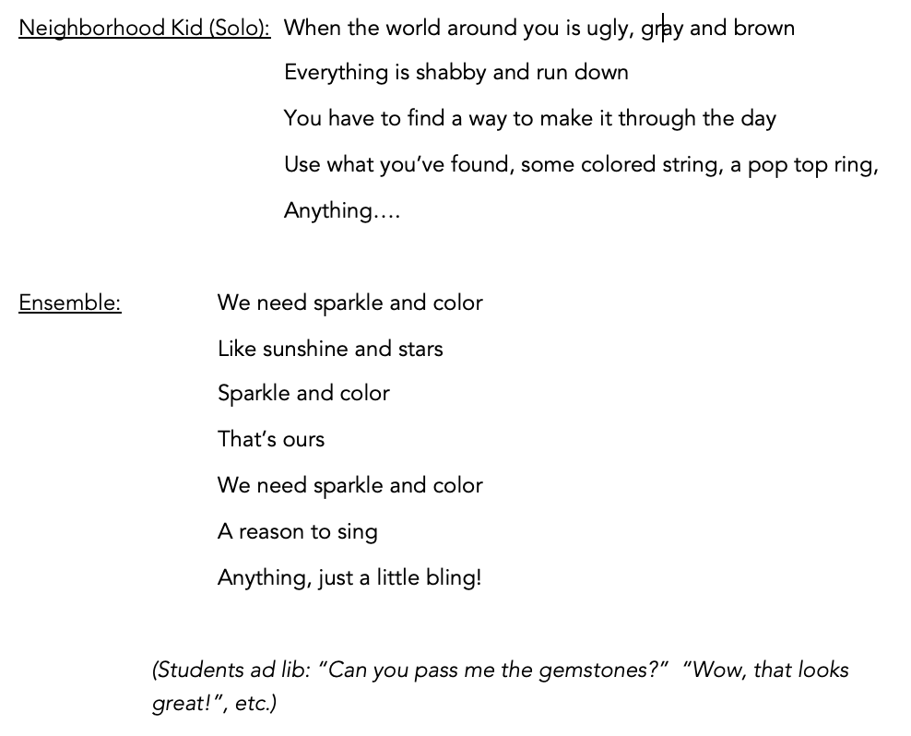
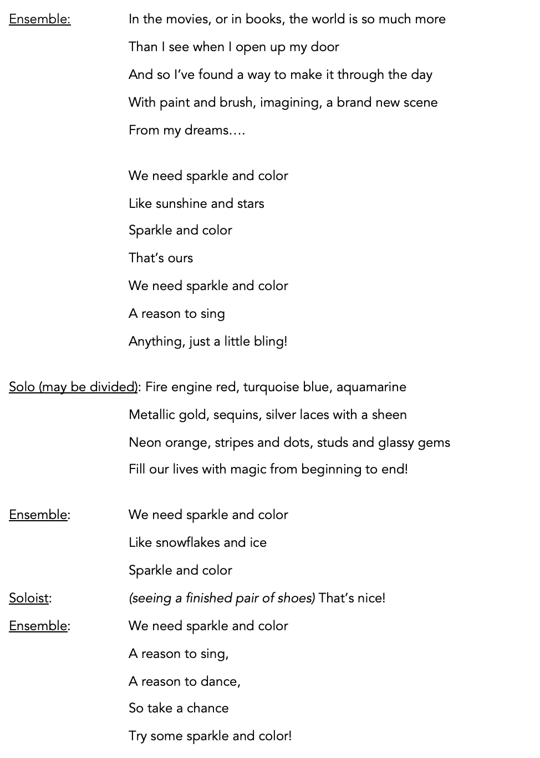
ALEAH: Thanks, Finn! They look great!
(ALEAH spins around and kicks out her feet. PENNY joins her and they do a move together.)
NEIGHBORHOOD KID 2: Hey, let’s have a dance!
STUDENT 1: Yeah! We could meet in the park again and I’ll bring my big speaker.
PENNY: Let’s do it! My shoes don’t want to stop! (she keeps moving.)
(Other kids agree. “Yea, let’s dance!” “How about Friday?”, etc.)
ALEAH: We could do it Saturday night. And everyone should come in their ‘new’ shoes.
STUDENT 2: I’ll make posters and hang them up afterschool tomorrow.
ALEAH: (gathering her supplies) Thanks, Finn. I’ll see you at school, Penny.
(ALEAH and STUDENTS exit)
PENNY: Okay! Bye! Thanks, Finn! I still can’t believe you let me wear your shoes today.
FINN: You don’t really know a person till you walk in their shoes! (Smiles, waves goodbye.)
(PENNY does a little dance move by herself, then heads to her car. She looks around to make sure no one is watching and climbs in. A moment later, ALEAH reappears holding a roll of duct tape and looks around, confused. She stops and looks at PENNY’s car, then walks over and taps on the window.)
ALEAH: Penny?
PENNY: (Opens door, embarrassed) Oh, I thought you went home.
ALEAH: I thought you did too, but I forgot to give your duct tape back.
PENNY: (Taking tape) I’m just, um, waiting for my dad to take me home. He’s……in the store.
ALEAH: The tires are flat. I think you’ll be here awhile. (smiles understandingly) Don’t worry – I won’t tell anyone that you live in your car.
PENNY: (Getting out of car) I didn’t always live here. After Mom died, Dad got sick and there wasn’t any money to pay the rent. Things will get better…I hope.
ALEAH: I’m sorry. It must be hard.
PENNY: But today was the best day I can remember. And the dance will be great! I’m so excited!
ALEAH: Me, too. I’ll see you tomorrow.
PENNY: Bye. Thanks, Aleah.
ALEAH: No problem.
(ALEAH exits.)
(PENNY sings the last few lines of “Sparkle” again to herself as she takes off her shoes, puts them in the trunk, then climbs in her car.)
Cue Track 14. Sparkle and Color – Reprise (Scene Change)

SCENE SIX – CLASSROOM
(More kids have artsy shoes. They sit at desks, but they are fidgety and keep moving their feet. Each sound seems to have a rhythm – the pencil sharpener, passing papers, tapping erasers – and the kids move in sync.)
TEACHER: Class, you are a fidgety bunch today! Please try to sit still.
(TRAVIS enters.)
TRAVIS: Oh, great. More weird shoes.
STUDENT 1: You’re just jealous.
TRAVIS: Yeah, right. I’ve got a whole store full of real shoes.
PENNY: Not everybody can afford your shoes
(A number of students agree.)
TRAVIS: Well, too bad for you.
(He has a sudden thought.)
TRAVIS: You know……if you want to make a little cash, you could sell me your shoes. I’ll resell them in the store.
ALEAH: I thought you said our shoes were ‘weird.’
TRAVIS: They are weird, but sometimes weird sells.
NEIGHBORHOOD KID 1: (To others) I wouldn’t trust him.
NEIGHBORHOOD KID 2: Yea. Travis only looks out for himself
(Others agree.)
Cue Track 15. Partners

TRAVIS: You could be passing up a good deal. Maybe you should think about it.
(STUDENTS ignore him. TRAVIS looks thoughtful.)

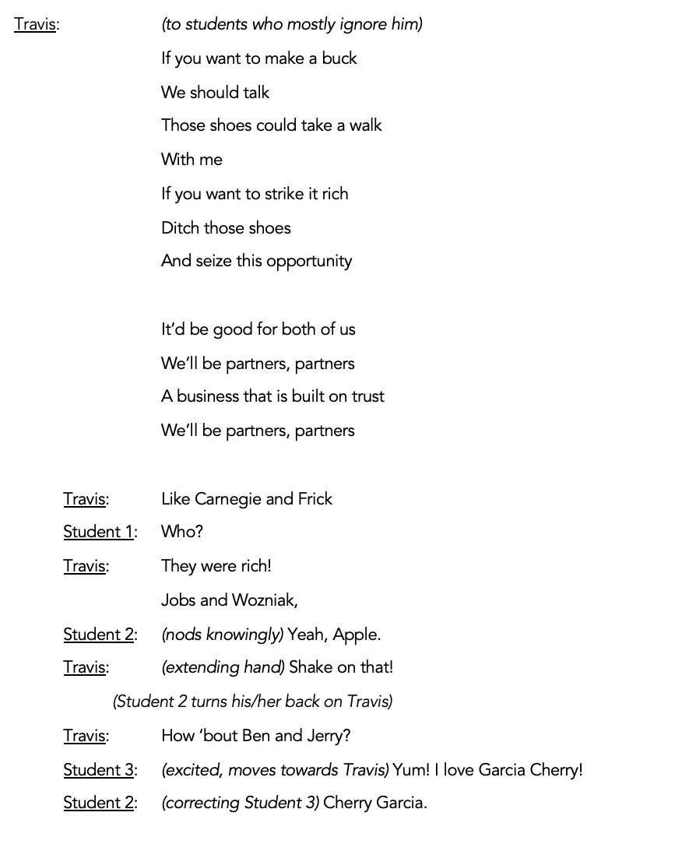

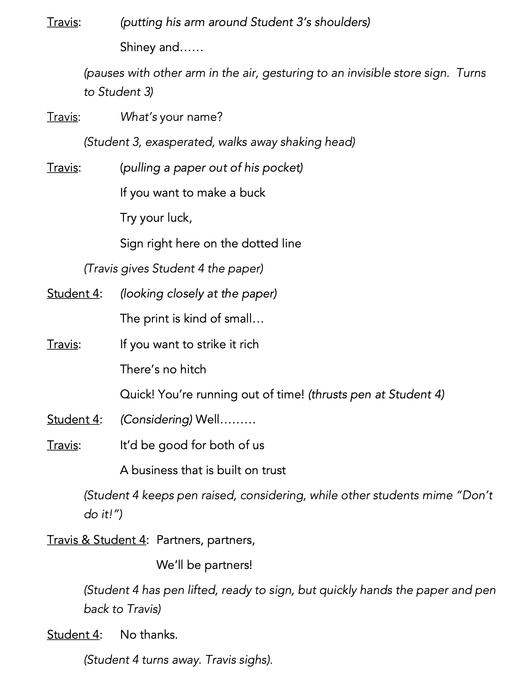

TEACHER: I hope you’ve all finished your work. Travis, you’ve done a lot of wandering. Clean up and get those backpacks ready to go home!
(TRAVIS packs his backpack and exits with STUDENT 4, still trying to convince him to sign. DESKS ARE REMOVED while ALEAH unrolls a poster advertising the dance at the park and shows PENNY.)
ALEAH: Penny, look at the poster I made for the dance!
PENNY: Wow! That looks great!
STUDENT 5: Let me see! (other students gather around)
STUDENT 6: Can we come?
ALEAH: Sure! Anybody can come. We’re decorating after school. We could use some help.
STUDENT 5: I don’t know where that park is.
ALEAH: You can come with me. I’ll show you.
(Other students: “I can come, too!” “Meet me at the bus stop on 6th street” “I’ll wait for you.” etc.)

SCENE SEVEN – THE STREET
(Students leave school dancing)
Cue Track 16. Kick It Up!

NEIGHBORHOOD KID 1: I can’t wait! We need this dance!
NEIGHBORHOOD KID 2: Yea, nothing good ever happens in this neighborhood.

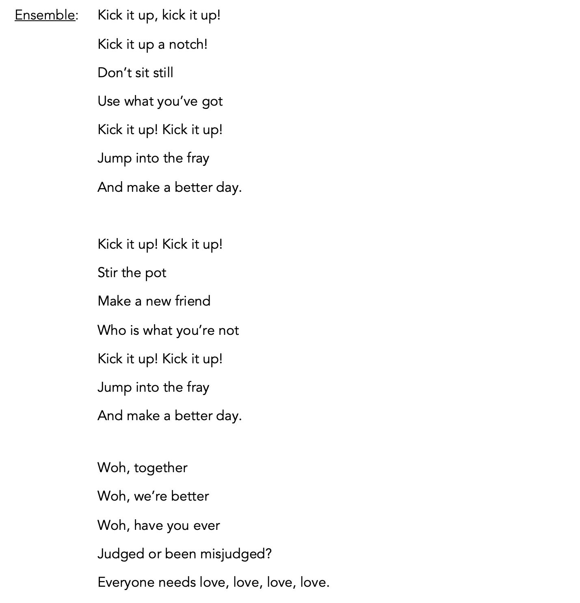
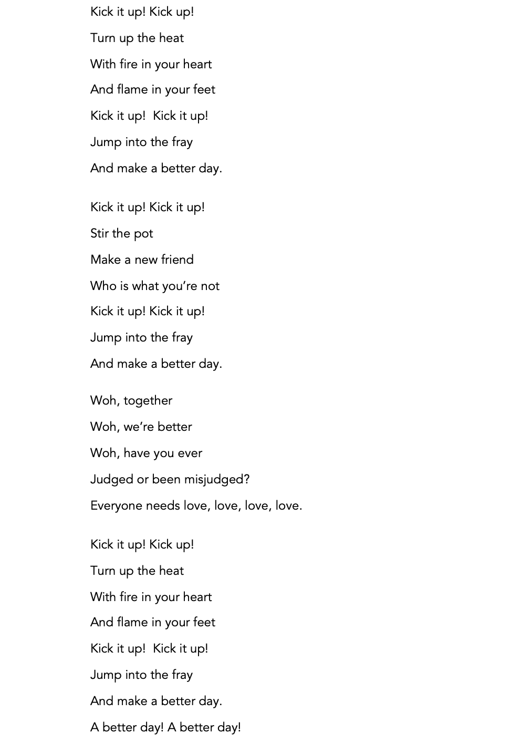
Cue Track 17. Kick It Up! – Reprise (Scene Change)
SCENE EIGHT – SHINEY’S SHOE SHOP
(Travis is madly rushing around carrying stacks of shoeboxes. Lots of talk and commotion as customers try on shoes.)
CUSTOMER 1: (To Travis) Young man! Young man! I need these in a size 8, not 9!
CUSTOMER 2: (Stopping Travis) Excuse me. Can I try these in a 6 wide?
CUSTOMER 3 (a man): (To Travis) Clerk! You brought me the wrong size! I told you I need a 12!
CUSTOMER 4 (a woman): (Trying on shoes with a busy young child) Jakey! Jakey! You get back here!
(She chases him while wearing just one shoe)
TRAVIS: (Rushing to hand CUSTOMER 3 a box) Here you go, sir. Here’s a 12!
CUSTOMER 3: (Pulls out brightly colored high heels and makes a face) These are lady’s shoes! You expect me to try these on?
(Child is pulling shoes off the shelves)
Cue Track 18. Service, I Want Service

CUSTOMER 4: (sitting and trying on more shoes) Jakey! Stop that! I’m going to count to three. One, two…two and a half, two and three quarters… (she chases him)
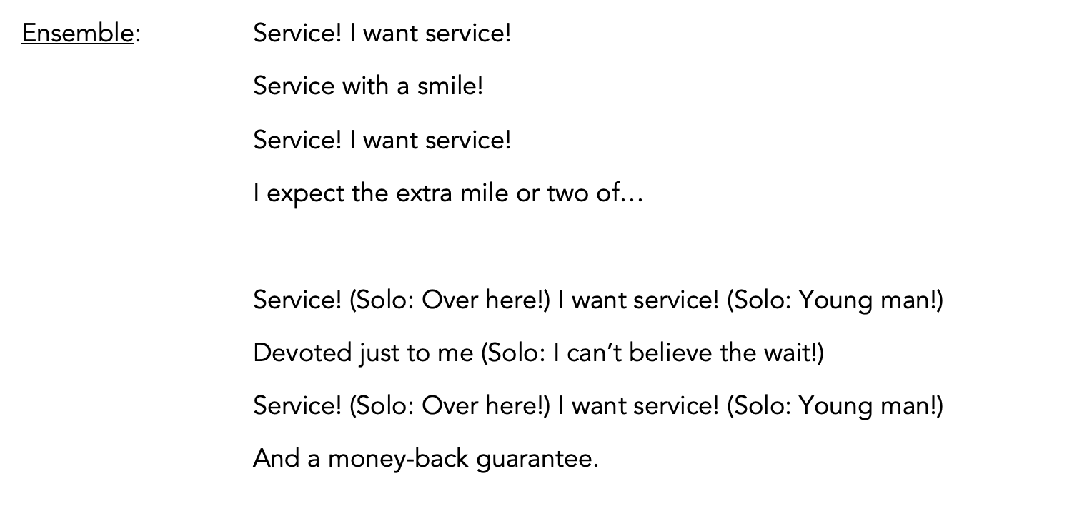
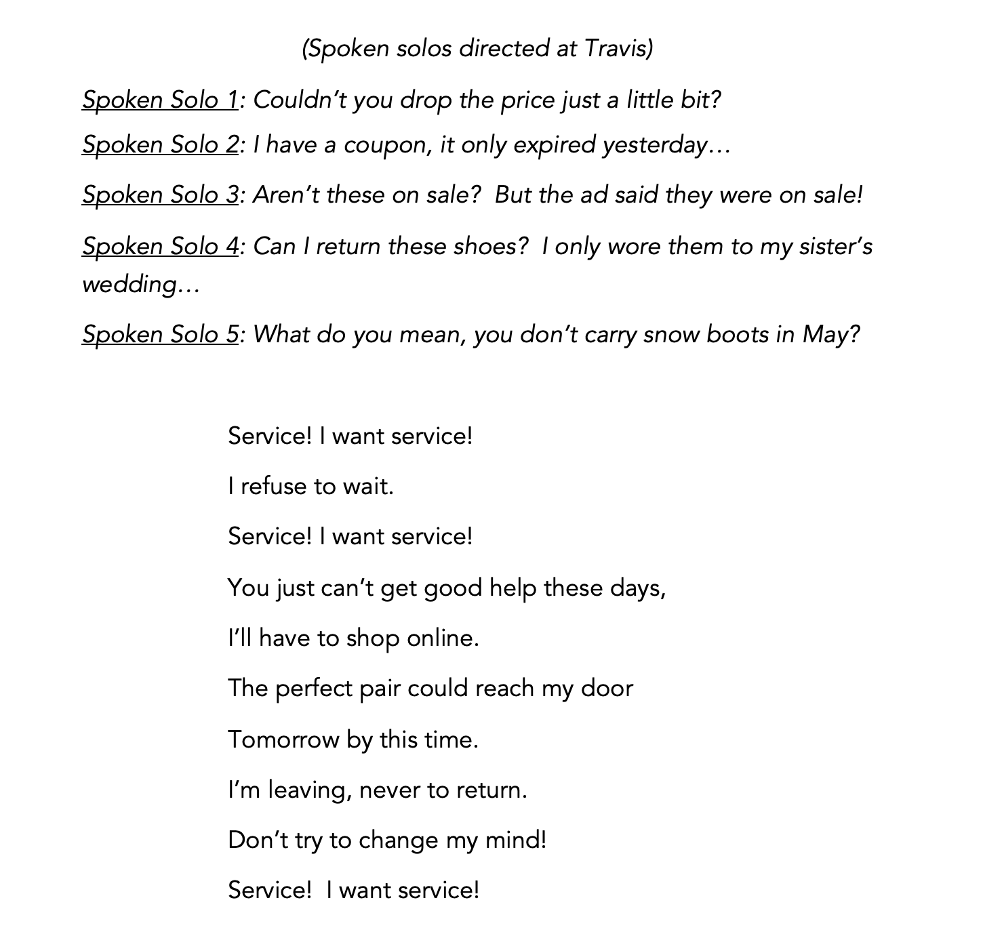
(Song ends. Customers, still complaining loudly, exit. TRAVIS collapses into a chair.)
TRAVIS: (To KELLY, who is casually putting shoes in boxes) If I have to smell one more pair of feet…
KELLY: Well, if you want that $1,000 prize, you might have to smell a few more. Hold your nose.
TRAVIS: But I’m so close! Just a few more to go.
KELLY: You’ve sold so many shoes, we’re running low on inventory. There isn’t much left to sell.
TRAVIS: (Concerned) Really? I’ve been so busy, I didn’t even notice. The trucks from the factory don’t come till Monday and the month is over tomorrow night. I need to sell 500!
KELLY: Well, you can’t sell what you haven’t got.
(STUDENTS in decorated shoes pass the store on the street, singing “Kick It Up!” and dancing as they cross the stage. They exit. TRAVIS runs to door and leans out, then closes it and turns to KELLY.)
TRAVIS: (Smiling) Maybe we don’t need new shoes. Old shoes might sell too. Old, weird shoes…
(TRAVIS grabs his coat and leaves)
Cue Track 19. Service, I Want Service – Reprise (Scene Change)

SCENE NINE – PENNY’S STREET
(Morning, street sounds.)
Cue Sound Effect 20. City Street Sounds
(PENNY gets out of car, stretches, does a little dance step, sings to herself, opens trunk. Suddenly she stops singing and starts rummaging around frantically)

NEIGHBORHOOD KID 1: (Entering barefoot) Penny! Someone took my shoes!
PENNY: Mine, too! Why would anyone want my shoes?
(FINN and more kids enter barefoot. “Who would steal shoes?!” “I loved those shoes!” “Now what do we do?”)
(ALEAH enters with other classmates, still wearing their decorated shoes)
ALEAH: (Concerned) What’s wrong? Where are your shoes?
NEIGHBORHOOD KID 1: (Sighing) They’re gone.
ALEAH: Gone? Where?
PENNY: Stolen.
STUDENT 1: Who would steal your shoes?
NEIGHBORHOOD KID 1: Who wouldn’t steal our shoes?
NEIGHBORHOOD KID 2: When you’re homeless, nothing is safe! (others agree)
PENNY: (Sadly) I loved those shoes……
NEIGHBORHOOD KID 3: It’s no use trying to have something nice.
NEIGHBORHOOD KID 2: Something cool.
PENNY: Finn, what can we do?
FINN: You can’t make something from nothing. Even with my brains (points to his temple), I can’t do anything about this one.
STUDENT 1: Don’t worry about it. They’re just shoes.
STUDENT 2: You can get another pair.
NEIGHBORHOOD KID 3: (Sarcastically) Right. From where?
ALEAH: You just go buy another pair!
NEIGHBORHOOD KID 3: With what? You don’t know what you’re talking about.
ALEAH: (Hotly) What do you mean? Somebody takes your shoes, you go buy more!
NEIGHBORHOOD KID 2: Maybe you do. I go barefoot. Those were the only shoes I had, and I don’t have rich parents to buy me another pair.
ALEAH: My parents aren’t rich!
NEIGHBORHOOD KID 1: If they can buy you new shoes without waiting till payday, they’re rich. And if you can still eat the next week, you’re really well-off!
(Others agree. “Shoes are expensive,” “I never get anything new,” “I’ve been wearing these for two years,” etc.)
(ALEAH and classmates look humbled)
ALEAH: I’m sorry. I didn’t know it was such a big deal.
NEIGHBORHOOD KID 1: Well, try going barefoot for a while and then tell me how you feel.
NEIGHBORHOOD KID 2: Crummy.
NEIGHBORHOOD KID 3: Ashamed.
PENNY: I’ll tell you - worthless.
(Pause)
NEIGHBORHOOD KID 3: (Suddenly remembering) And the dance is tonight! We were going to wear our cool shoes.
NEIGHBORHOOD KID 2: I’d like to know who took them.
PENNY: I bet I know.
NEIGHBORHOOD KID 1: There’s only one person who really wanted our shoes.
ALEAH, PENNY, & CLASSMATES: Travis!
NEIGHBORHOOD KID 4: Because we wouldn’t sell him our shoes, he stole them.
NEIGHBORHOOD KID 2: I bet he’d never admit it though.
NEIGHBORHOOD KID 3: So now what do we do? Just go barefoot?
STUDENT 1: Around here? Probably not a good idea.
PENNY: How can we have a dance when we don’t even have shoes?
(All are silent for a moment)
ALEAH: We can still have the dance!
PENNY: Maybe you can. I don’t feel like dancing anymore.
ALEAH: You will! I have an idea!
(CLASSMATES: “What?” “It won’t be fun now” “We need shoes, not a dance”)
ALEAH: We’ll move the dance to the gym at my church on 2nd street. And you don’t need to worry about shoes. Just be there at 7:00. We can still do this!
(Excited, ALEAH exits with classmates. NEIGHBORHOOD KIDS gather in small groups at benches. PENNY, looking despondent, sits on a bench downstage. Finn sits down next to her.)
FINN: A “penny” for your thoughts.
(He smiles at his own pun and gently bumps his shoulder against hers.)
PENNY: Very funny. I just want my shoes back. That Travis is a lowlife.
FINN: We’ll figure it out. Use what you’ve got (taps temple, as before.)
PENNY: (Shrugs) I haven’t got much. I’m just a “penny,” remember?
FINN: A penny still has value. Haven’t you heard about those people who collect pennies in jars for years? My grandma had one. It’s worth a lot more than you think. It adds up.
PENNY: And your point is…?
FINN: You are worth something, and so is everyone else. Everybody has value. And if we all put our value together instead of trying to go it alone, we’d be a lot better off.
PENNY: I don’t want to go it alone, but what if other people don’t want me around?
FINN: Not everyone is gonna see your value. But since you are a Penny, you might as well be a shiny penny.
(PENNY rolls her eyes)
FINN: I mean it. Be your best self. Whether people see your value or not, just shine.
Cue Track 21. Let It Shine (This Little Light)

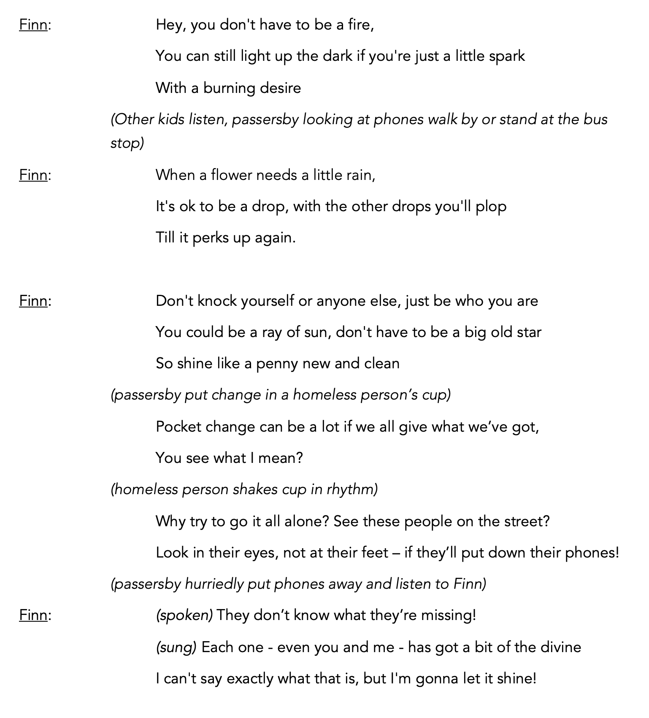
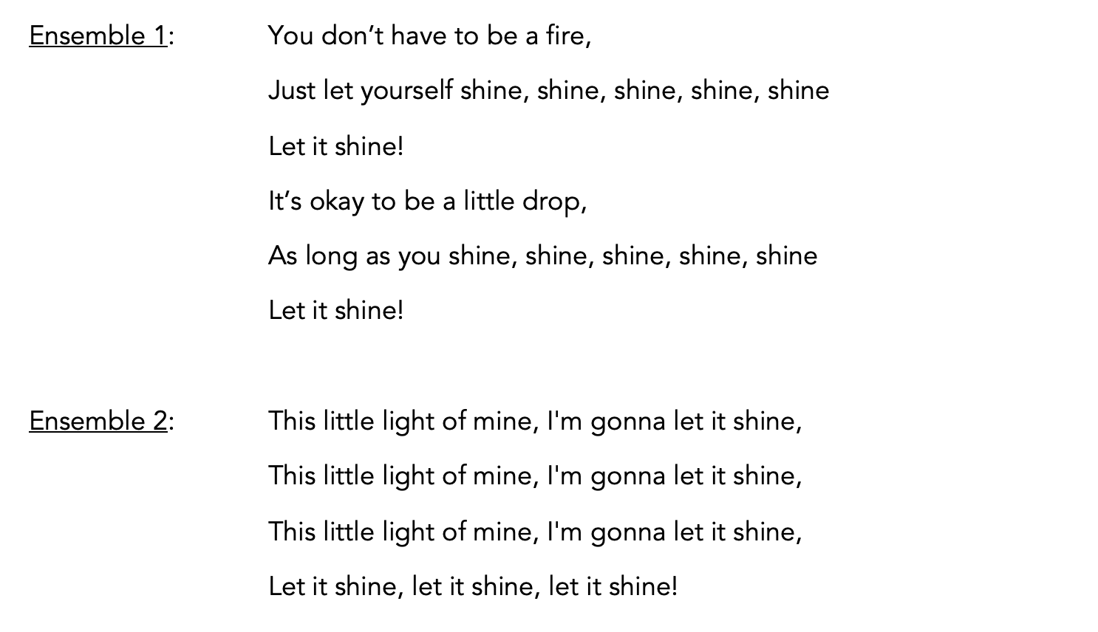
Cue Track 22. Let It Shine (This Little Light) – Reprise (Scene Change)

SCENE 10 – SHINEY’S SHOE SHOP
(TRAVIS is at the cash register. He is wearing decorated high tops.)
TRAVIS: (Handing bag to customer) Thank you, sir/ma’am. Please come again.
(Customer exits.)
TRAVIS: (To KELLY who is reading a magazine) That’s 499! I’m almost there!
KELLY: (Still reading) I don’t know, Travis. You still have to sell one more pair and there are only 10 minutes before we close. And almost no shoes left.
(KELLY gestures to almost empty shelves.)
TRAVIS: You have to admit, I saved the day with those cool shoes.
KELLY: I don’t know where you got them, but they flew off the shelves!
TRAVIS: Yep. I just have an eye for what sells. That’s why I’m going to win this competition.
KELLY: Well, you’d better do it fast.
TRAVIS: And here comes number 500…
(TRAVIS runs to greet a customer, a teenager, coming in the door.)
TRAVIS: Welcome to Shiney’s Shoe shop. How can I help you today?
CUSTOMER: Well, duh. I need shoes.
TRAVIS: Of course. Certainly. What size are you looking for?
CUSTOMER: (Looking around) Ten. But your shelves are kinda empty. I think I’ll look somewhere else. (turns to go)
TRAVIS: (Desperate) No! Wait! I’m sure we can find something for you in a ten.
CUSTOMER: (Looking at Travis’s feet) I like what you’re wearing. Never seen shoes like those. Do you have a pair in a size ten?
TRAVIS: Well, no…
(CUSTOMER sighs, turns again to leave)
TRAVIS: Wait…these are a size ten. Do you want to try them on?
Customer: (Turning back) You’d sell me your shoes?
TRAVIS: Well, uh, sure. Why not?
(JORDAN walks into the shop, barefoot, interrupting them)
TRAVIS: (To JORDAN) Hey! Read the sign. (gestures to sign on door) “No shirt, no shoes, no service.”
JORDAN: That’s why I’m here! No shoes. (puts bare foot out)
TRAVIS: Sorry. Can’t help you. Our shelves are empty.
JORDAN: (Looking at Travis feet) Hey! Those are my shoes!
CUSTOMER: (To JORDAN) Those are yours?
TRAVIS: (Flustered) He just doesn’t want to buy any.
JORDAN: You’re the one who stole my shoes! I put those colored laces in myself. Look! I still have an extra!
(JORDAN pulls out a matching shoelace)
TRAVIS: No way, bro.
CUSTOMER: You stole this kid’s shoes? That’s really low! I’m not buying stolen goods. (He turns toward the door)
TRAVIS: No, wait! I can sell you something else! Don’t go!
(Customer leaves. KELLY, who has been watching this play out, stands up and points to her watch.)
KELLY: Well, that’s it. Time to close.
TRAVIS: (Sinking into a chair, head in hands) No……I almost had him. Number 500! (He forgets about Jordan)
JORDAN: I want my shoes back!
KELLY: Hey, Travis. If those are his shoes, you’ve got to return them.
JORDAN: Yea. Give ‘em back. You have a whole shoe store! Why’d you have to take the only shoes I own?
TRAVIS: (Sitting up, looking at kid, sighs) I don’t know. I just wanted to win. (He begins taking off shoes) Dad would have been proud of me.
KELLY: Are you sure about that? Proud of selling stolen shoes?
JORDAN: (Taking his shoes from Travis) Thanks. I guess.
(JORDAN puts shoes on as Travis watches, then leaves)
TRAVIS: Dad keeps saying he works really hard just so he can build a successful business to pass on to me. But what if I’m not good at business? What if I destroy everything he’s worked for?
KELLY: Travis, you’re just a kid! You’ve got plenty of time to learn the business. And he wouldn’t want you to steal to get ahead.
TRAVIS: (Shrugs) Probably not.
KELLY: If you really want to make him proud, why don’t you do something for the kids who can’t afford to buy shoes?
TRAVIS: If I’d won the $1,000, I could have helped someone.
KELLY: Would you really have given it away?
TRAVIS: (Thinks) Nope. Probably not. (Pauses, looks at his feet) But now I’m just like that kid. I don’t have shoes either!
KELLY: You’ve still got more than him, I bet. A lot more.
(TRAVIS shrugs but doesn’t answer)
KELLY: (Sighs, looks around) There’s almost nothing left on the shelves. Nothing that fits you, anyway.
(KELLY holds up a pair of sparkly little girl’s shoes. TRAVIS laughs.)
TRAVIS: I guess it’s my turn to go barefoot.
KELLY: I’m sure you’ve never been without shoes.
TRAVIS: Nope. Never.
KELLY: You did the right thing. You returned that kid’s shoes.
TRAVIS: But I can’t return the rest – they’re gone. Sold.
KELLY: If you think about it, I’m sure you can find a way to make it right for those other kids too. And make your dad proud. (She grabs a bag and heads towards the door.) Well, time to go home. Don’t step in any puddles. (She smiles and exits)
Cue Track 23. If You Could Walk in My Shoes – Reprise (Scene Change)

SCENE 11 – DANCE
(Dance in gym at Aleah’s church, which is decorated like a 1950’s sock hop. Records decorate the walls.)
Cue Track 24: Gotta Dance
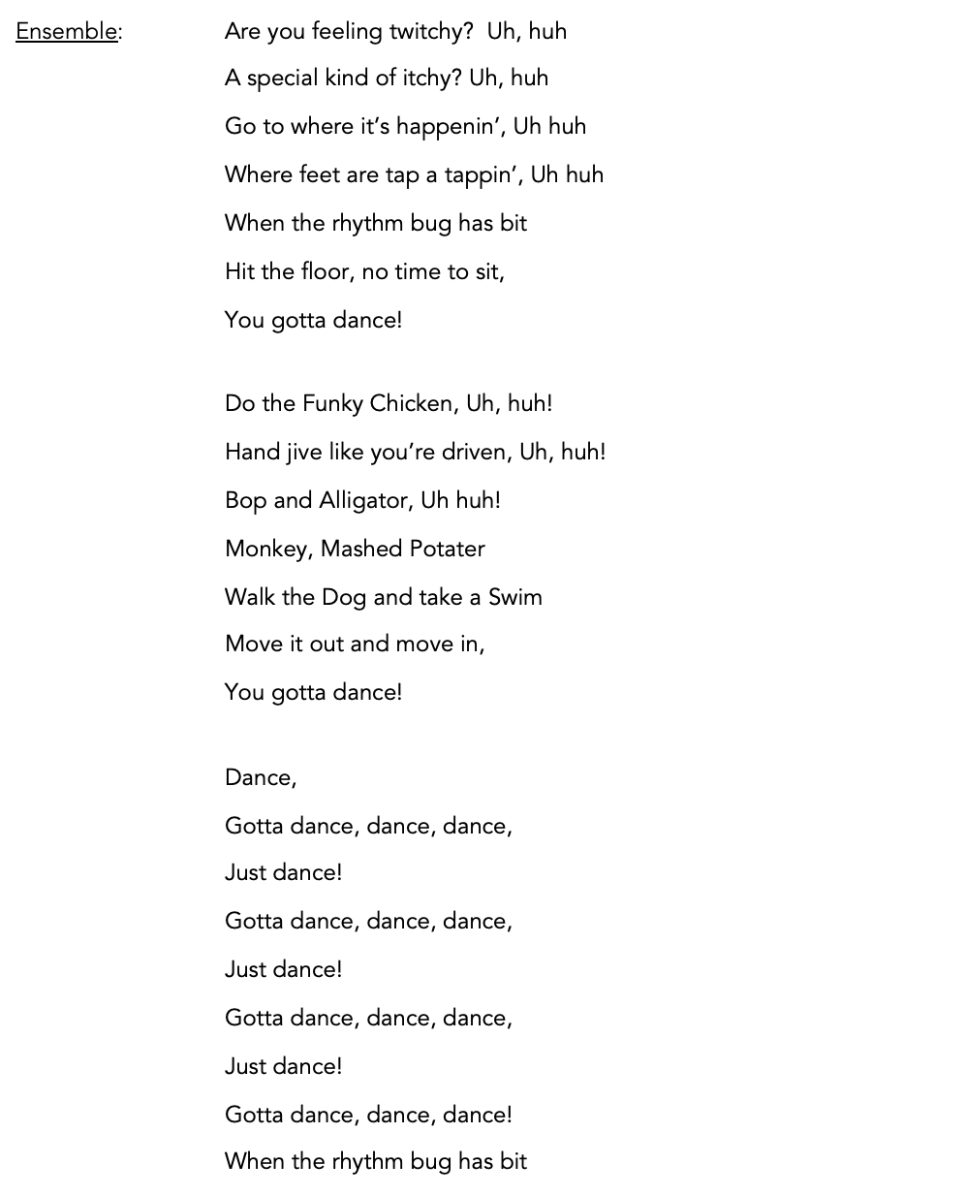
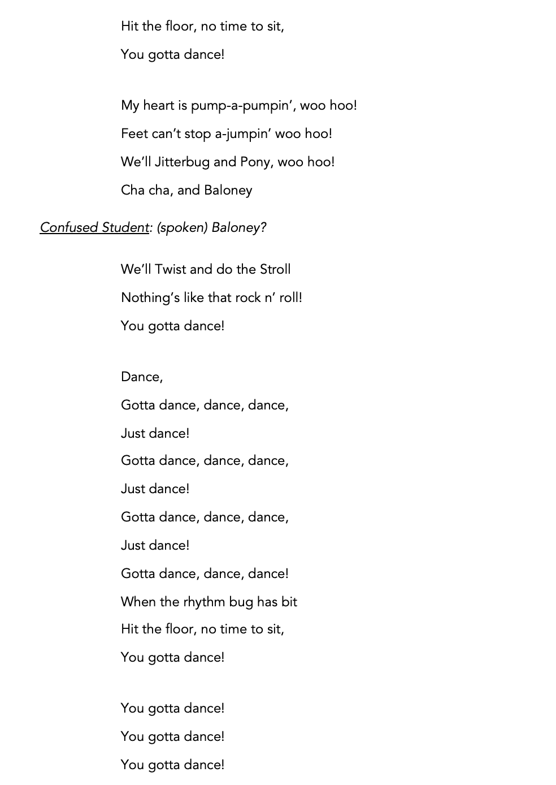
ALEAH: (To PENNY) I told you we could still have the dance!
PENNY: Thanks for doing this. It was really nice of you to make sure the dance went on.
ALEAH: No problem. No one wears shoes to a sock hop!
PENNY: It was fun. The only thing is……we still don’t have shoes.
ALEAH: Yes you do. Everyone who came and left their shoes at the door for the dance is going home barefoot tonight. They’re leaving their shoes for the kids who need them.
PENNY: Really? They’d give them to us? Don’t they know what it’s like to go barefoot?
ALEAH: I guess it’s time to find out.
(TRAVIS enters, barefoot, carrying boxes of shoes)
TRAVIS: Hey. I hope it’s ok if I show up at your dance.
PENNY: How come you’re barefoot? (Other kids gather around)
TRAVIS: Um…well…I’m really sorry but…I took your shoes.
(Kids all at once: “I told you he took them!” “You just can’t trust Travis” “Why’d you take our shoes? You said they were weird!”)
TRAVIS: I know, I know. But I could have won $1,000! I just needed to sell 500 pairs. (Pause as other students gather around) I’m really sorry I took them. I just wanted to win. I can’t get your shoes back, but I brought some others. I hope that’ll be ok for now.
(Kids shrug, open some boxes. Ad lib: “It’s better than nothing,” “My sister could wear these...” etc.)
TRAVIS: Your shoes were awesome. If I get some more high tops, could you decorate more? Customers really liked them. My dad could pay you.
(Kids: “Maybe.” “They were really awesome.”)
TRAVIS: And I’m sure he’d want to use the profit to make that neighborhood you live in a better place. There are too many people without shoes—or even a place to live. I could help.
PENNY: (Skeptically) Are you sure? What do you know about my neighborhood? What do you even know about me?
Cue Track 25: Finale
TRAVIS: I don’t. I’m sorry. But when you’re barefoot, it’s easier to listen. And now… (looks down at his own bare feet and back up) …I’m listening.
